**Project Design Phase-II**

**Technology Stack (Architecture & Stack)**

|  |  |
| --- | --- |
| Date | 31 Oct 2023 |
| Team ID | NM2023TMID04450 |
| Project Name | Building a website using Canva |

**Technical Architecture:**

The technical architecture for a clothing brand's online presence involves a combination of hardware, software, and infrastructure to support its website, e-commerce platform, and other digital systems.

The Deliverable shall include the architectural diagram as below and the information as per the table1 & table 2

**Example: Order processing during pandemics for offline mode**

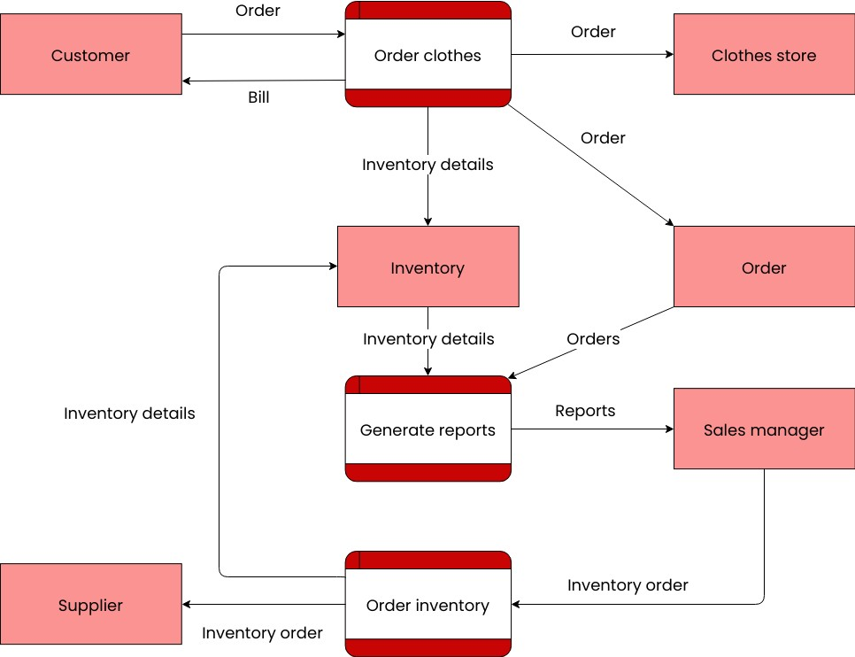

**Table-1: Components & Technologies:**

|  |  |  |  |
| --- | --- | --- | --- |
| **S. No** | **Component** | **Description** | **Technology** |
|  | User Interface | Choose a colour scheme that reflects the theme of your costume design website. Consider colours that are commonly associated with costumes, fashion, or the style you want to convey. | Computer-Aided Design (CAD),3D Modeling Software,Wearable Technology. |
|  | Application Logic-1 | Profiles can include personal information, portfolio, and design preferences. | PHP,Ruby,Python |
|  | Application Logic-2 | Include features for adding descriptions, materials, and tags. | Virtual Reality,Photogrammetry, Augmented Reality (AR). |
|  | Application Logic-3 | Implement a virtual try-on feature for users to see how the costume might look on them. | Clothing Simulation Software,Machine Learning and Computer Vision. |
|  | Database | Determine what information you need to store for costume design, such as costume details, materials, images, designers, and events. | MySQL, NoSQL. |
|  | Cloud Database | Amazon RDS (Relational Database Service) provides managed database instances for popular RDBMS like MySQL, PostgreSQL, and SQL Server. | Azure SQL , IBM Db2 on Cloud |
|  | File Storage | A cloud storage service that allows you to store, organize, and share costume design files. It also integrates well with Google Workspace applications. | Augmented Reality (AR) and Virtual Reality (VR) |
|  | External API-1 | Widely used for sketching and creating detailed costume designs and technical drawings. | 3D Virtual costume Fitting |
|  | External API-2 | A vector graphic design software similar to Adobe Illustrator, suitable for costume design sketching and illustration. | Digital Textile Printing Tools |
|  | Machine Learning Model | Machine learning models can be trained to recognize and classify different types of fabrics and materials, helping designers make informed choices based on factors like texture, colour, and durability. | AI-Generating Design Concepts |
|  | Infrastructure (Server / Cloud) | A physical workspace equipped with design tables, sewing machines, dress forms, and other tools necessary for costume design and creation. | Design Studio and Computer workstation |

**Table-2: Application Characteristics:**

| **S. No** | **Characteristics** | **Description** | **Technology** |
| --- | --- | --- | --- |
|  | Open-Source Frameworks | A physical workspace equipped with design tables, sewing machines, dress forms, and other tools necessary for costume design and creation. | Clo3D,LibreCAD |
|  | Security Implementations | Encrypt sensitive costume design files and communications, especially when sharing them over networks or storing them in the cloud. | Firewalls and Intrusion Detection/Prevention Systems (IDS/IPS) |
|  | Scalable Architecture | Use a modern front-end framework like React, Angular, or Vue.js for building the user interface. This allows for modular design and easy scalability as you add more features. | Machine Learning and AI |
|  | Availability | Popular costumes may be in high demand during certain times of the year, such as Halloween. | AP and Microservices |
|  | Performance | This relates to the effectiveness and quality of costume design for a specific purpose, such as a theater production, film, or special event. | E-commerce platforms and cloud computing |